**SOFTWARE PROJECT TEAM MEMBERS.**

|  |  |  |
| --- | --- | --- |
| ***TITLE*** | ***NAME*** | ***REGISTRATION NO.*** |
| **PROJECT MANAGER** | **KASEMA JAMES LUTEGO** | **21100533350037** |
| **DEVELOPER** | **ISMAIL SAID SEIF** | **21100533350031** |
| **DEVELOPER** | **DAUD EPAPHRAS MWIGAMBA** | **21100533350020** |
| **ANALYSTS MANAGER** | **IRFAN AHMAD BHATTI** | **21100533350010** |
| **PRODUCT DESIGNER** | **NEEMA WILFRED YOHANA** | **21100533350021** |
| **TESTER** | **NEEMA SAYI MAYOMBO** | **21100533350044** |

SOFTWARE REQUIREMENT DOCUMENT: MUST ONLINE VOTING WEBSITE SYSTEM.

**INTRODUCTION**

**PURPOSE**

The purpose of this document is to build the online system for university voting to ease the election process.

**DOCUMENT CONVENTIONS**

This document uses the following conventions.

|  |  |
| --- | --- |
| DB | Database |
| ER | Entity Relationship |

**INTENDED AUDIENCE AND READING SUGGESTIONS**

This project is a prototype for the online voting system and it is restricted within the college premises. This has been implemented under the guidance of course instructor. This project is useful for the election process.

**PROJECT SCOPE**

The purpose of the Must online voting system is to ease Election process and to create a convenient and easy-to-use application for student, trying to vote their leaders. We will have a database server supporting hundreds of students who will be voting during the election. Above all, we hope to provide a comfortable user experience along with the free pricing available.

**SYSTEM LIMITATION/ CONSTRAINTS**

* An internet connection is required to cast the votes

**TOOL AND TECHNOLOGY**

Following are the tools and technologies that will be used for the development of the web system.

|  |  |  |
| --- | --- | --- |
| **Tools**  **and**  **Technologies** | **Tools** | **Version** |
| Virtual studio code | 1.77 |
| Notepad++ | V8.5.2 |
| **Technology** | **Version** |
|  | HTML | 5 |
| CSS | 3 |
| PHP | 7.4 |
| JavaScript | ES6 |

**OVERALL DESCRIPTION**

**PRODUCT PERSPECTIVE**

A distributed voting database system stores the following information.

* **User accounts:**

These accounts will contain information of students include course, year of study and name of student.

* **Ballots:**

Ballots will include ballot data.

* **Votes:**

Inside database of votes, election result will be included.

**PRODUCT FEATURES**

The major features of MOVS database system as shown in below [**entity–relationship model**](https://en.wikipedia.org/wiki/Entity%E2%80%93relationship_model) (**ER model**)

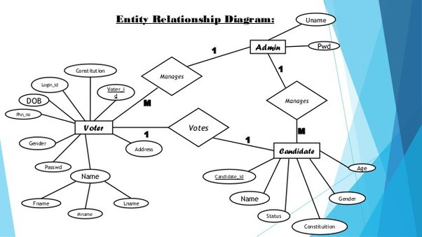

The diagram shows the layout of MOVS database system – entity–relationship model.

**OPERATING ENVIRONMENT**

Operating environment for the MOVS is as listed below.

* client/server system
* Operating system: Windows, MAC OS.
* database: sql+ database
* platform: HTML/CSS/PHP /JavaScript.

**EXTERNAL INTERFACE REQUIREMENTS**

**USER INTERFACES**

* Front-end language: HTML, JavaScript and CSS.
* Back-end: SQL+PHP.

**HARDWARE INTERFACE**

* Windows & Mac OS.
* Computer & Phone with 4RAM+
* Processor – intel core i3+
* Phone processor’s 2GHz+

**SOFTWARE INTERFACES**

Following are the software used for the Must online voting System.

|  |  |
| --- | --- |
| **Software used** | **Description** |
| Operating System | We have chosen Windows and MacOS for its best and user-friendliness. |
| Database | To save the user info’s, ballot data and election results we have chosen SQL database. |

**COMMUNICATION INTERFACES**

This project supports all types of web browsers. We are using simple languages such as HTML, CSS, PHP and JavaScript.

**FUNCTIONAL REQUIREMENTS**

Following are the functional requirement of our system:

1. **Authorize User**

It will authorize every user before letting him vote.

1. **Add Nominee**

It will allow to add nominee

1. **Vote Virtually**

Voter can vote at any part of the world through web-system.

1. **Vote anonymously**

Data of the voter will be safe in Database.

1. **Vote Once**

Any authorized can only vote once in an election.

1. **Accuracy**

The system shall record and count all the votes and shall do so correctly.

**NONFUNCTIONAL REQUIREMENTS**

Following are the nonfunctional requirement of our system:

1. **Registration**

The voter registration shall be done in person only.

1. **Secrecy / Privacy**

No one should be able to determine how any individual voted.

1. **Reliability**

Election systems should work robustly, without loss of any votes, even in the face of  
numerous failures, including failures of voting machines and total loss of network communication.

1. **Simplicity**

The system shall be designed to be extremely simple.

1. **Performance**

Our system will be fastest vote casting software.

1. **Support**

As it is written in php so it can open in any platform like in mobile, laptop or tab browsers.